**“Play is the Way”**

**Paula Douglas, Rachel Frew and Nicola Blain**

**Abstract**

It is now widely accepted that play is an essential part of learning and development for children particularly in the early years and that this approach to learning and teaching has had a positive impact on confidence and attainment within the lower stages of primary education. This has led to an increase in schools and teachers successfully implementing a child centred, play based approach to learning in the lower stages of primary school to deliver all areas of the curriculum. As children grow up, play remains just as important to their learning and development. However, there has been limited research into the impact of a child centred, play based approach to learning in the upper stages of primary school. Here we investigate the impact of implementing a play based approach to learning on pupils’ health and wellbeing in two upper primary classes. Following a return to school after a period of home learning we asked pupils from two classes to complete a health and wellbeing survey. Pupils rated themselves against the school values relating to; resilience, respect, confidence, happiness and love of learning. We then delivered an 8 week block of learning and teaching using a child centred, play based approach. At the end of the block of learning, pupils were asked to complete a second survey, again asking them to rate their health and wellbeing against the school values. Our initial findings indicated that there had been a substantial increase in pupil health and wellbeing and overall engagement in learning following a play based approach to learning. This suggests that play based learning has a significant impact on pupils learning and development in upper primary.

**Introduction:**

Children’s play is crucial to Scotland’s wellbeing; socially, economically and environmentally (Scottish Government, 2013b). The UNCRC (1989) lists ‘play’ as a universal right which all children internationally should have access to. In Scottish context there has been a commitment to uphold this right which is evident in recent publications namely: Realising the Ambition: Being Me (Scottish Government, 2020), the Play Toolkit (Play Strategy for Scotland, 2017); the Play Rangers Toolkit (Scottish Government, 2014) which focuses primarily on the importance and delivery of play-based learning experience in Early and First learning environments as well as the Refreshed Curriculum Narrative (2019) which pledges a commitment to child-centred pedagogy. However, despite both the national and international policy outlined, and the benefits of play evidenced throughout this study, it is clear that there exists little emphasis or research concerned with play beyond the age of 8 years old. This research therefore seeks to explore the impact of child-centred pedagogy (learning through play) on children in the middle-upper primary school’s health and wellbeing in the post COVID-19 lockdown context. This study has taken an empirical approach to the area of study by which two baseline surveys were administered to assess aspects of pupils’ health and wellbeing in relation to our school values: confidence, respect, resilience, happiness and love of learning following post-lockdown transitions to school to allow us to identify what, if any are the main benefits of learning through play beyond the age of 8.

**Background:**

**What is Play?**

Firstly, for the purpose of this research it is important to gain an understanding of, and what is meant by ‘play’. The term ‘play’ can be best thought of as an evolving term, used in many different ways to serve several different purposes. According to Palmer (2020; p.31) ‘play’ is a very misused adult word which often evokes connotations of unimportant recreational things we do when we are not working. However, for children, play is a way of life. In his article, Gray (2013) lists the five most agreed characteristics of play: 1) self-chosen and self-directed, 2) intrinsically motivating, 3) guided by mental rules while still supporting creativity 4) imaginative and 5) it is conducted in an active frame of mind. The characteristics are reflected in The Scottish Government’s definition of ‘play’ which states:

*“Play encompasses children's behaviour which is freely chosen, personally directed and intrinsically motivated. It is performed for no external goal or reward and is a fundamental and integral part of healthy development which seeks to improve play experiences for all children." (2013b, p.14).*

**More than ‘just’ play**

Although the definitions and purposes of ‘play’ may differ, it is clear that play has benefits for all aspects of children’s development (Eberle, 2014). The importance of play in children’s daily lives and healthy development has become increasingly researched and accepted in recent years (ibid, 2014; Palmer, 2020). Playworkers such as Sue Palmer (2020) emphasise that play is crucial to achieving children’s optimal health and wellbeing and acts as a powerful builder of happy, healthy, capable children.

For many children, play is often a social experience which encourages interactions with their peers and the adults around them. Playing freely with others encourages children to develop important social skills such as seeing things from others perspectives, cooperating, sharing, helping and solving problems through, for example, sharing toys, agreeing to work together and communicating effectively within a group or team (UNICEF, 2018; Play Scotland, n.d). These social skills learned through play are a powerful builder in supporting children’s companionship and relationships with others around them (Ramstetter, Pellegrini and Garner, 2010).

Play also allows young children the opportunity to explore their emotions and express themselves in a relatively safe environment. When children are playing, they are emotionally immersed in their play, often developing a sense of the emotional aspects of everyday lives. Evidence also suggests that play can provide opportunities for children to develop greater resilience and coping strategies to overcome stress and difficult situations through the development and understanding of relationships and through experiencing positive feelings and reactions (Play Scotland, n.d).

**Play in Policy**

This emphasis on play also extends into international policy as the United Nations Conventions on the Rights of the Child (UNCRC) (1989) lists ‘play’ as a fundamental right to which all children from 0 to 18 years old internationally should have access to. According to the UNCRC (2013), schools play a major role in fulfilling the obligations of Article 31 (1) and (2), relating to leisure, play and culture, which states that;

*1. Parties recognize the right of the child to rest and leisure, to engage in play and recreational activities appropriate to the age of the child and to participate freely in cultural life and the arts.*

*2. States Parties shall respect and promote the right of the child to participate fully in cultural and artistic life and shall encourage the provision of appropriate and equal opportunities for cultural, artistic, recreational and leisure activity*

A review of Article 31 in Scotland was published in 2014 which states that children’s rights as commissioned by Article 31 have not been given sufficient attention (SCCYP, 2014) and since, Scotland has further supported the implementation of play within their policy context. The Scottish Government published its first Play Strategy Our Vision (2013a) to support the implementation of Article 31 in Scotland which sets out a clear vision for Scotland to become “a nation which values play as a life-enhancing daily experience for all children and young people” (Scottish Government, 2013a; p.1). This document was later followed by Play Strategy for Scotland: Our Action Plan (Scottish Government 2013b) which provides greater clarity as to how the play strategy will be implemented into practice to fulfil the vision and principles outlined. Both documents discuss, in detail, the importance of play within a school environment and outline the role of the schools and nurseries in fulfilling the vision and principles outlined in their previous document and Article 31 which states the following:

*All children and young people enjoy high quality play opportunities, particularly outdoor free play in stimulating spaces with access to nature, on a daily basis in school, nursery and early learning and childcare.*

This commitment to promoting play is also evident within the Scottish Government’s rationale in the Refreshed Curriculum for Excellence Narrative (2019) in which they pledge a commitment to putting children at the heart of the curriculum (child-centred pedagogy) to ensure challenge and enjoyment, personalisation and choice. *Many of the Scottish policies published more recently: namely Realising the Ambition: Being Me (Scottish Government, 2020), the PlayTypes Toolkit (Play Strategy for Scotland, 2017) which makes recommendations for educators to consider allowing more opportunities for play in schools as part of lesson structures.* It links different types of play: socio-dramatic, loco-motor and rough and tumble play to the Experiences and Outcomes of the Curriculum for Excellence (CfE) (Scott-McKie and Casey, 2017).

However, looking across all of the experiences and outcome indicators under each curricular area within the CfE, it is clear that the role of play-based learning is most prevalent in the health and wellbeing experiences and outcomes within primarily Early Level and First Level. For example:

* *“In everyday activity and play, I explore and make choices to develop my learning and interests. I am encouraged to use and share my experiences. HWB 0-19a*
* *Through taking part in a variety of events and activities, I am learning to recognise my own skills and abilities as well as those of others. HWB 1-19a.”*

This suggests that the Scottish Government are committed to delivering a curriculum through play. However, looking across second level experiences and outcomes however, there is very little mention of the ‘play’ as a mechanism fulfil the second level indicators and despite both national and international policy outline, and the benefits of play evidenced above, it is clear that there exists very little emphasis or research concerned with play beyond the age of 8 years old.

**Conclusions**

The importance of play in children’s daily lives and healthy development has become increasingly recognised in recent years. It is clear that Scotland recognise the benefits which play has on children’s health and wellbeing within an early years setting and in recent years, have committed themselves to upholding children’s right to play commissioned in the UNCRC’s Right of the Child (2013) through their publication of a series of documents namely: Realising the Ambition: Being Me (Scottish Government, 2020), the Play Toolkit (Play Strategy for Scotland, 2017); the Play Rangers Toolkit (Scottish Government, 2014) focus primarily on the provision of play within early and first level. The Scottish Government have also committed to delivering a “child centred” curriculum with a focus on play which is evidenced within Early and First level experience and outcome indicators. This play-based curriculum approach however excludes upper primary school pupils. Furthermore, despite the growing body of research evidence which promotes play-based learning to support children’s health and wellbeing, there exists very little emphasis on the benefits of play-based learning for middle-upper primary children. This limited scope of literature dedicated to play in the middle- upper primary stage therefore presents an opportunity for further research to be conducted in order to explore and identify whether the discussed benefits extend beyond early to first level.

# **Research Design**

**Aim:** The aim of this research project is to explore the impact of child-centred pedagogy (learning through play) on health and wellbeing in the post COVID-19 lockdown context.

**Research Objectives:**

* To assess aspects of pupils’ health and wellbeing in relation to our school values: Respect, Resilience, Confidence, Happiness and Love of Learning following post-lockdown transitions to school;
* To investigate the impact of child-centred pedagogy on pupils’ wellbeing in relation to these values;
* To identify key wellbeing needs in relation to the values and positively impact on pupils’ health and wellbeing through a child-centred approach to identify what, if any, are the main benefits of learning through play beyond age 8.

**Methodology**

This research aims to u explore the impact of child-centred pedagogy (learning through play) on health and wellbeing in the post COVID-19 lockdown context. This research will be carried out by an empirical approach. After careful consideration of both qualitative and quantitative methods, it has been decided to proceed with a single-method quantitative approach in order to meet both the aims and objectives of this project and research constraints regarding time. By Jupp’s (2014) definition, quantitative research is an approach which focuses on the collection of data in a numerical form for quantitative analysis which can be scores, rating or scales.

**Research Methods**

Baseline surveys have been chosen as the best course of action as according to Cohen *et al*. (2018), surveys are powerful research tools as they allow for data regarding attitudes and opinions to be gathered in an efficient and economical way. This is particularly important for this research enquiry as learners’ personal attitudes and opinions are sought. The survey administered a Likert scale, Bell and Waters (2016) suggests that this is a suitable research tool for children as it allows them to present their attitudes and opinions in an intelligible way, which best suits the aim and objective of the proposed research.

Learners undertook this baseline survey at the beginning and end of the research timeframe in which they self-assessed against our school values (confidence, happiness, respect, resilience and love of learning. The purpose of which was to accurately measure the impact of child-centred pedagogy on children’s health and wellbeing by comparing the pre baseline assessment with the post baseline assessment which allowed us to gain a direct comparison and identify the impact which child centred pedagogy has on children’s health and wellbeing.

This study focussed on a cohort of 35 learners from two middle- upper primary (P5-7) classes across 2 partnership schools. For this research we were issued with a £500 EIS action research grant to resource the research enquiry. This allowed us to resource the provision of child-centred pedagogy in both middle-upper school classrooms. Specifically, this has involved the development of free play classroom zones such as a creative zone, S.T.E.M (science, technology, engineering and maths) zones and resourcing suitable approaches to providing a child-centred curriculum and child-led learning experiences.

**Ethical Considerations:**

Perhaps one of the greatest ethical considerations arising from this study is one concerned with protecting privacy. Hammersley and Traianou (2012) emphasise the importance of maintaining confidentiality and anonymity throughout the research process, from the data collection, to the research publication. In terms of this research, anonymity was achieved through the use of pseudonyms instead of real names in all aspects of the research. The issue of confidentiality was addressed from the outset, where participants were assured that those able to access data were limited to myself and research partner. This guarantee of anonymity and confidentiality, Bell and Waters (2014) argue, helps participants to respond honestly without fear of repercussion.

**Findings and Analysis**

In order to explore the impact of Child-centred Pedagogy on Health and Wellbeing in the Post-COVID-19 Context, we identified two cohorts of pupils (totaling 35 pupils) in upper primary we deemed best suited to carry out the research. At the beginning of our research project we gathered baseline quantitative data from both classes around pupil wellbeing, in relation to the school values they deemed important pre COVID-19. The school values that we were measuring were; Respect, Resilience, Confidence, Happiness and Love of Learning.

In our initial survey we asked all pupils to rate themselves against each statement relating to the school value using a rating scale of; strongly disagree, disagree, neutral, agree and strongly agree. This gave us an overall idea of the baseline health and wellbeing of pupils in the classes and allowed us to identify which areas of health and wellbeing were rated the lowest.

The baseline data was as follows:

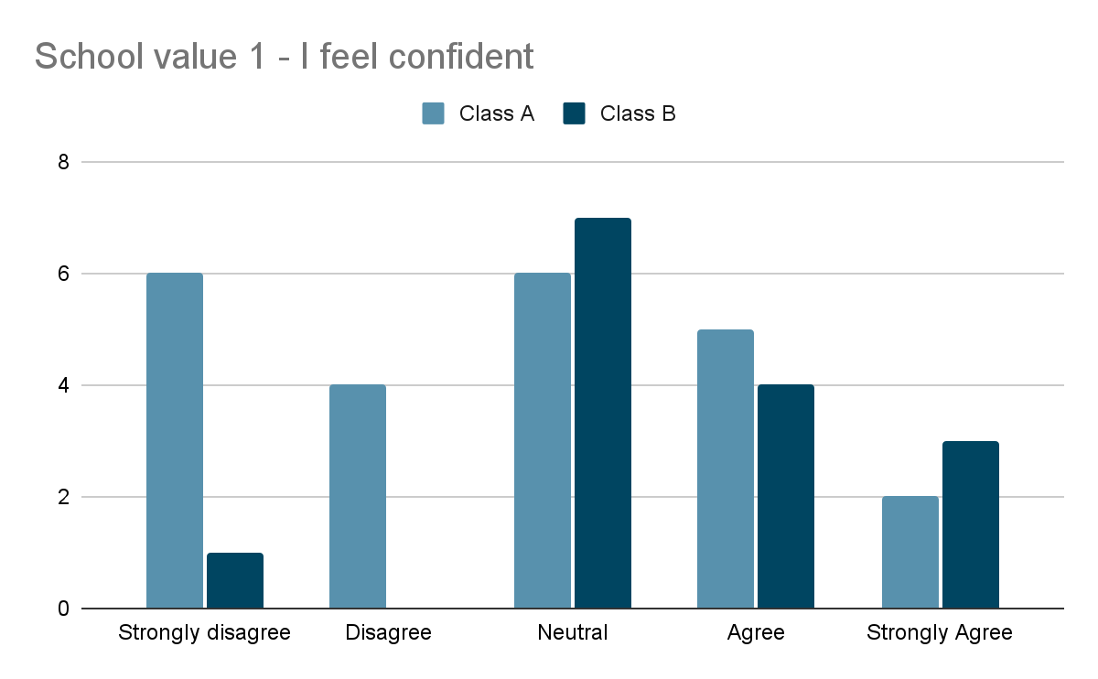

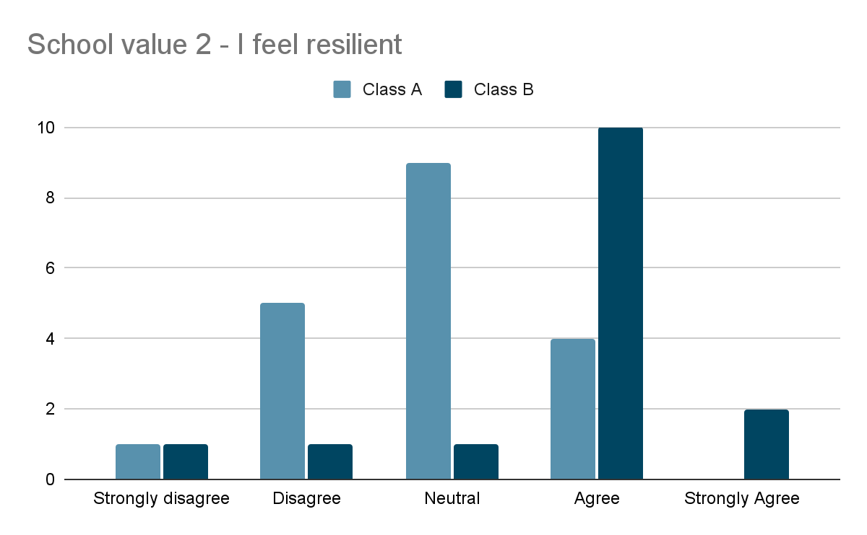

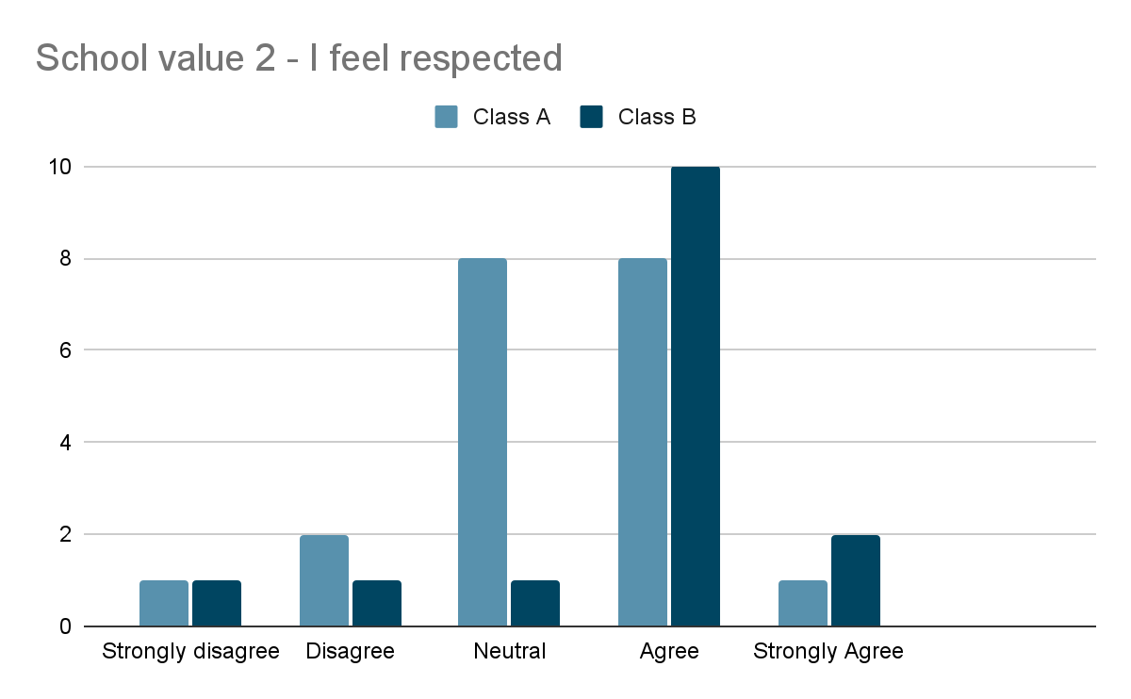

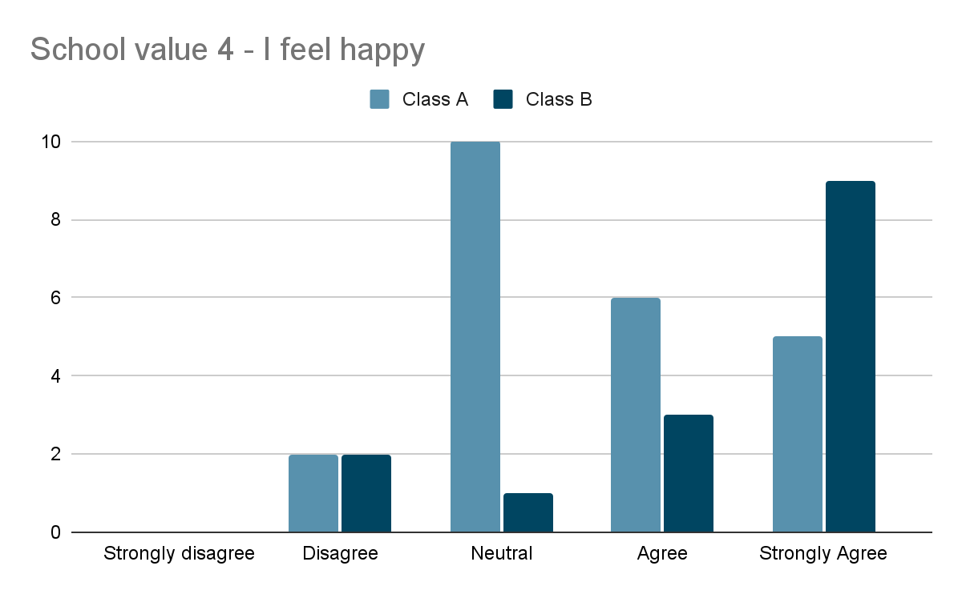

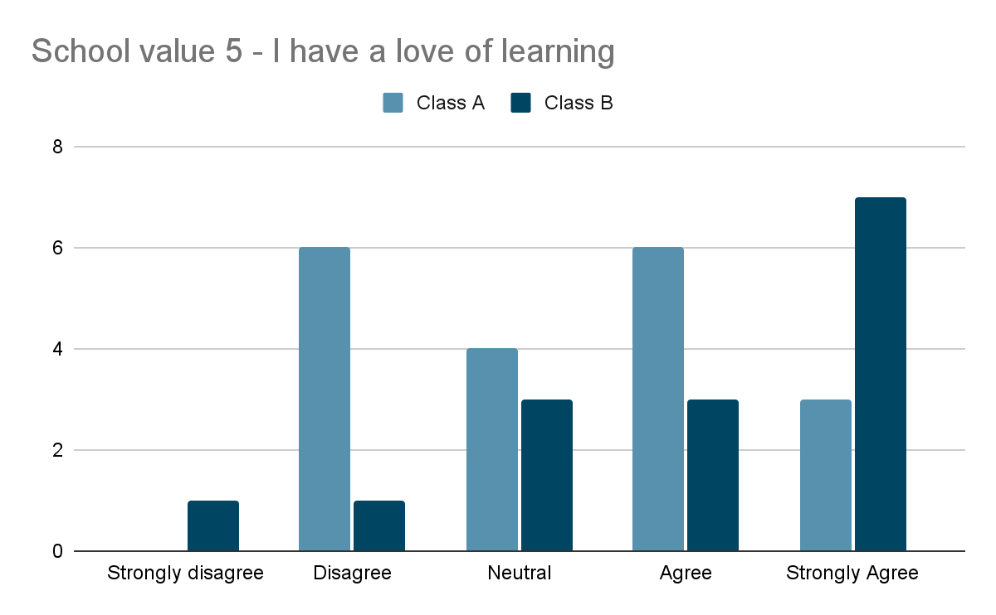

The initial data indicated that class A showed the lowest ratings with confidence and resilience. Class B showed their lowest ratings were with confidence and feeling respected. This backed up teacher judgement who had identified that resilience and confidence were lacking across both cohorts.

Throughout the research project teachers observed, evaluated and used their professional judgement to assess pupil engagement in their learning and noted any changes to pupil health and wellbeing that was evident within the classroom. It was noted that prior to implementing the play based learning there were several pupils who had been identified as being the most vulnerable in terms of their health and wellbeing needs and having the lowest engagement within the classes.

Following 8 weeks of implementing child centered pedagogy and play based learning in both classes, we asked the 35 pupils to complete the same survey in order to again rate themselves against each statement relating to the school values using the same scale of; strongly disagree, disagree, neutral, agree and strongly agree.

The results were as follows:

**School Value 1 – I feel confident**

**School Value 2 – I feel resilient**

**School Value 3 – I feel respected**

**School Value 4 – I feel happy**

**Schoole Value 5 – I have a love of learning**

The following table shows the percentage of pupils in each class who rated themselves higher against each school value in the final survey following the block of play based learning compared to the rating they gave themselves in the initial baseline survey.

|  |  |  |
| --- | --- | --- |
| School Value Statement | Class A % increase | Class B % increase |
| I feel confident | +60% | +47% |
| I feel resilient | +55% | +40% |
| I feel respected | +85% | +20% |
| I feel happy | +75% | +40% |
| I have a love of learning | +80% | +60% |

As you can see from the data it is immediately apparent that there has been a clear increase across both classes in relation to each health and wellbeing statement following the block of child centered pedagogy and play based learning.

Across the 8 weeks of research, teacher observations identified that in both class A and class B most pupils appeared to be happier and that productivity had increased significantly. The pupils initially identified to be the most vulnerable and least engaged with their learning prior to introducing play based learning had shown the biggest improvement in their love of learning, happiness and confidence.

In their comments on their post baseline assessment, children have commented on developing skills including;

* leadership
* problem solving
* creativity
* communication
* teamwork.

All pupils said that they preferred a play based approach to learning and commented that that they enjoyed;

* Choosing their learning
* Managing their own tasks
* Not having to sit at desks

It should also be noted that no pupils rated themselves lower against any of the health and wellbeing statements in their post baseline survey compared to their baseline survey.

In conclusion of this research study it can be seen that there has been a clear positive impact of child centered pedagogy on pupil health and wellbeing in a post Covid context. Using the data provided by the surveys and using teacher judgement, we can see that pupils are significantly happier, are demonstrating much more confidence, are more engaged with their learning tasks and have shown an increase in their love of learning. The benefits that we have identified through our short research project are encouraging however it must be noted that Child centred, play based learning is resource intensive. In order to implement it effectively it does require more space, resources and ideally more adult involvement. Only by continuing to implement a child centred pedagogy and assessing the impact over a longer period of time, will we truly know the real impact on pupil health and wellbeing. Furthermore, this research project has not explored any gender or socio economic data that may have affected the results. This is something that could and should be assessed in order to find the true impact of play based learning.

**References**

Bell, J. and Waters, S., 2016. *Doing Your Research Project*. 6th ed. Maidenshead: Open University Press.

Cohen, L., Manion, L. and Morrison, K. (2018). *Research Methods in Education*. 8th ed. Oxon: Routledge.

Eberle, S. G. (2014) The Elements of Play: Toward a Philosophy and a Definition of Play. American Journal of Play, Vol. 6, No. 2, pp. 214 – 233. [Accessed: 07/11/2020].

Jupp, V.,( 2014). *The SAGE Dictionary of Social Research Methods*. London: SAGE Publications Ltd

Palmer, S., 2020. *Play Is the Way*. Paisley: CCWB press.

Pellegrini, A. D. and Holmes, R. M. (2006) The Role of Recess in Primary Schools. In: D. G. Singer, R. M. Golinkoff and K. Hirsh-Pasek (eds.), Play = Learning: How Play Motivates and Enhances Children’s Cognitive and Social-Emotional Growth. [e-book] pp. 36 – 54. New York, NY: Oxford University Press. [Accessed: 01/11/2020]

Scott-McKie, L. and Casey, T. (2017) Play Types Toolkit: Bringing more play into the school day. [pdf] Play Scotland. Available at: . [Accessed: 26/03/2021].

Scotland’s Commissioner for Children and Young People (SCCYP). (2014) Children’s right to play, culture and arts: A review of Article 31 in Scotland. [pdf] Edinburgh: SCCYP. Available at: . [Accessed: 20/03/2021].

Scottish Government (2014) Play Rangers Toolkit. [pdf]. Scottish Government [Accessed 11/11/2020]

Scottish Government, (2020). *Realising The Ambition: Being Me*. Edinburgh: The Scottish Government.

Scottish Government. (2013a) Play Strategy for Scotland: Our Vision. [pdf] Edinburgh: Scottish Government. [Accessed: 11/11/2020].

Scottish Government. (2013b) Play Strategy for Scotland: Our Action Plan. [pdf] Edinburgh: Scottish Government. [Accessed: 07/11/2020].

Scott-McKie, L. and Casey, T. (2017) Play Types Toolkit: Bringing more play into the school day. [pdf] Play Scotland. [Accessed: 11/11/2020].

The Scottish Government, 2019. *Refreshed Curriculum For Excellence Narrative*. Edinburgh: The Scottish Government.

United Nations (UN). (2013) Committee on the Rights of the Child. General comment No. 17 (2013) on the right of the child to rest, leisure, play, recreational activities, cultural life and the arts (art. 31). United Nations: Geneva. [Accessed: 20/11/2020].

United Nations Convention on the Rights of the Child (UNCRC). (1989) Convention on the Rights of the Child. [pdf] London: UNICEF UK. [Accessed: 20/11/2020].

Jupp, V.,( 2014). *The SAGE Dictionary of Social Research Methods*. London: SAGE Publications Ltd